**44-599: Introduction to Data Visualization**

**Individual Tool Presentation**

**Objective:** To generate choropleth maps and candlestick charts by importing data from a database (MySQL) to plotly workspace – online chart editor using Virtual – Plotly Database Connector Server.

**Goals:**

1. Generating a Choropleth map by importing data from MySQL database to plotly workspace- online chart editor using Virtual-Plotly Database Connector server.
2. Importing data from MySQL database to generate a Candlestick chart.

Upon successful completion of this worksheet, you would be able to generate a choropleth maps and candlestick charts using the online version of plotly chart editor.

**Dataset:** Here provided the data excel sheets which only for data reference. Please make sure that you create tables in MySQL with the same data or different according to your interest.

**System environment:**

* Server: Plotly Database Connector.
* Database: MySQL.
* Database Interface: MySQL Workbench.
* Client: Plotly online chart editor.

**Installing required software:** For the goals stated above, it is required to install few software.

1. Setup the plotly database connector on a personal computer.

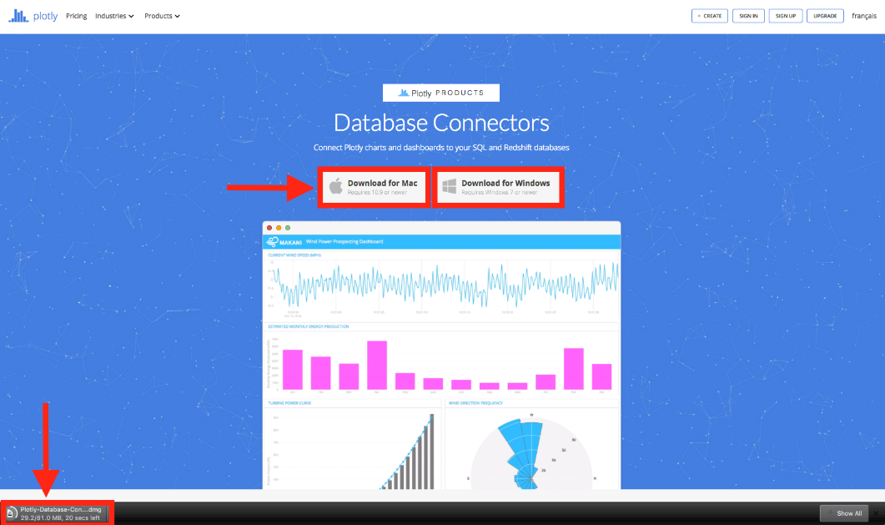Step 1: Download the plotly database connector from this link: <https://plot.ly/database-connectors/>

Step 2: Install the App

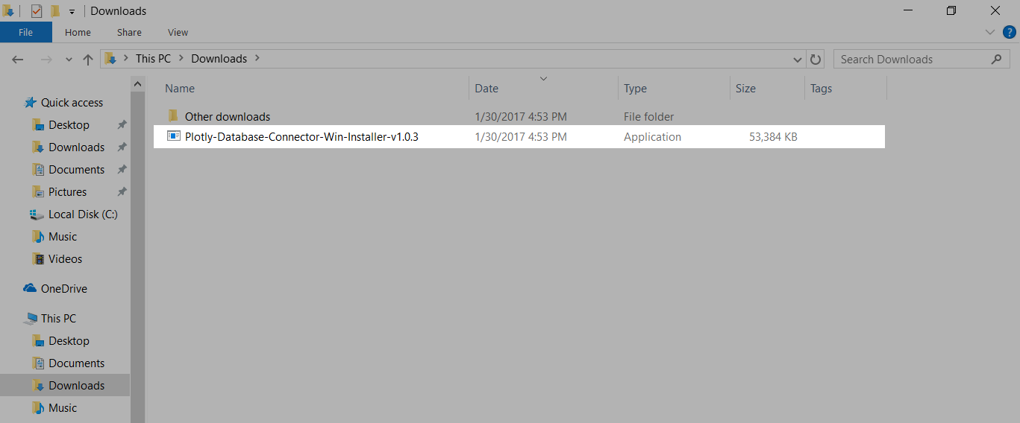

Step 3: Double click on the application. Your application will start to install itself.

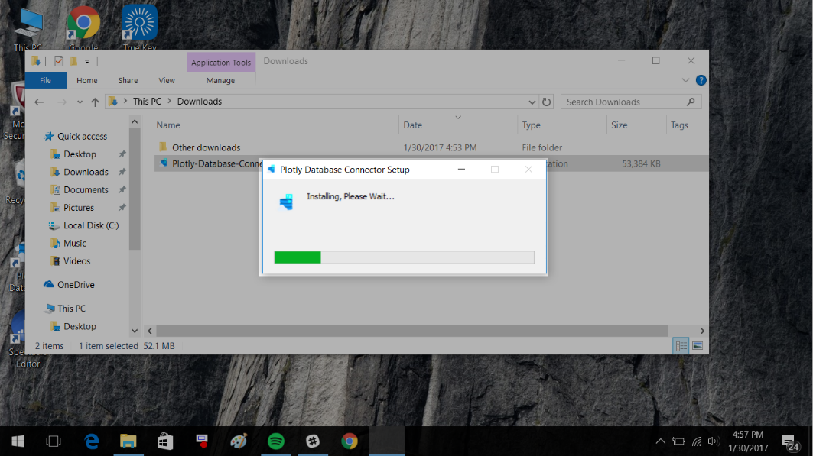

Step 4: Once installed, a desktop icon will be created on your desktop.

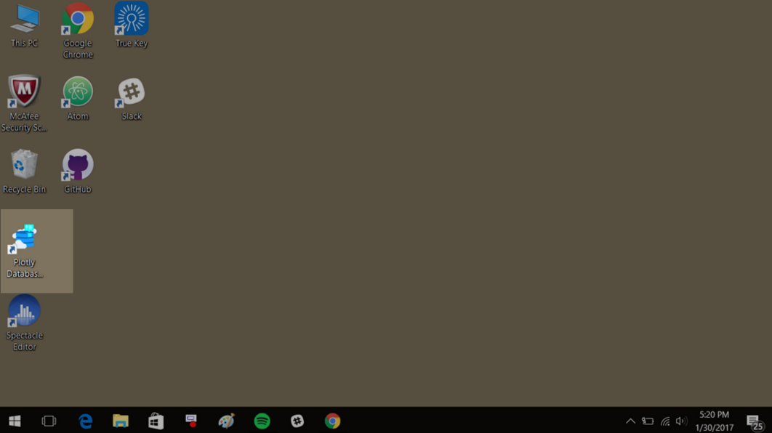

1. MySQL 5.7 requires the Microsoft Visual C++ 2013 Redistributable package to run on windows. So, install this package on the personal computer before installing the server. This package is available at <https://www.microsoft.com/en-us/download/default.aspx>
2. MySQL workbench requires the Microsoft Visual C++ 2015 Redistributable package to run on windows. . So, install this package on the personal computer before installing the workbench. This package is available at <https://www.microsoft.com/en-us/download/default.aspx>
3. In fourth step we need to install MySQL Community Server 5.7.18 and MySQL Workbench on a personal computer. In order to do this first we need to install MySQL Installer5.7. Go ahead and download the MySQL Installer5.7 from: <https://dev.mysql.com/downloads/mysql/>
4. After downloading, run the installer as an admin. Choose the appropriate setup type for your system. Typically you will choose Developer Default to install MySQL server and other MySQL tools related to MySQL development. Or, choose the custom setup type to manually select your desired MySQL products. Complete the installation process by following the MySQL installation wizard’s instructions. This will install several MySQL products and start the MySQL server.

**Note:** You probably also install other helpful MySQL products like MySQL Workbench and MySQL Notifier on your system. By default, these two programs automatically start after installing MySQL.

**Step 1:** To install MySQL using the MySQL installer, double click on the MySQL installer file and follow the steps below:

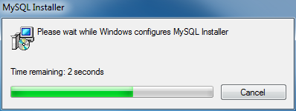

**Step 2:** Windows configures MySQL Installer

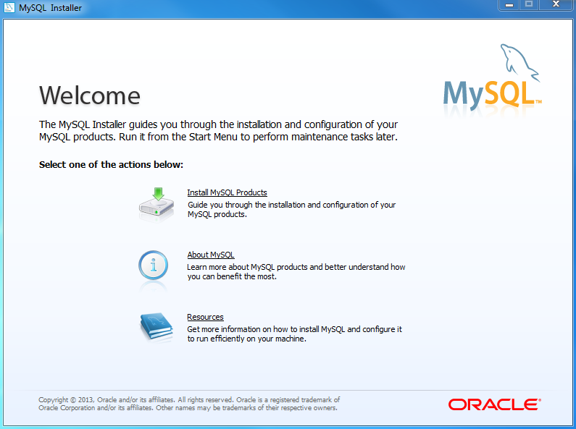

**Step 3:** Welcome Screen: A welcome screen provides several options. Choose the first option: Install MySQL Products.

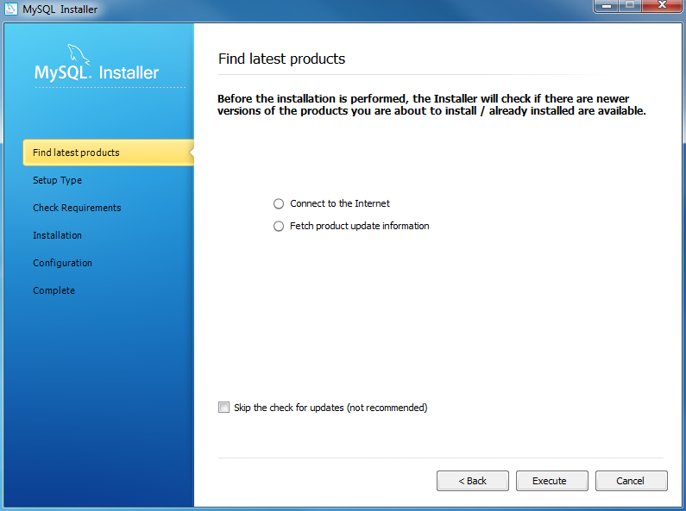

**Step 4:** Download the latest MySQL products: MySQL installer checks and downloads the latest MySQL products including MySQL server, MySQL Workbench, etc.

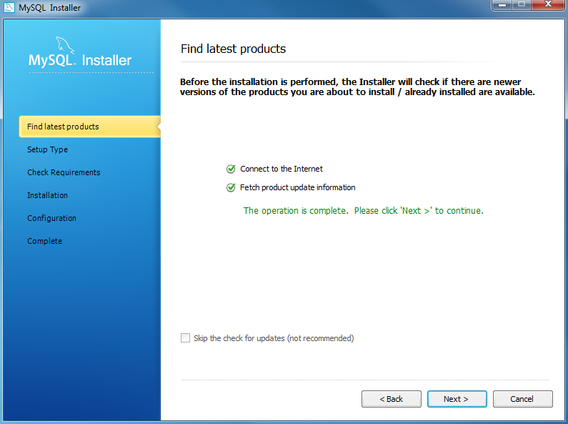

**Step 5:** Click Next button to continue.

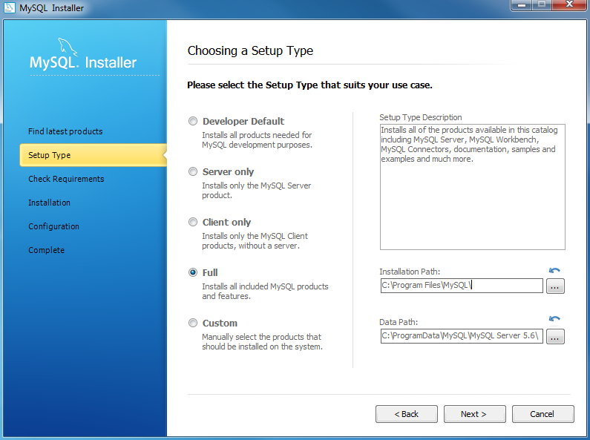

**Step 7:** Choosing a Setup Type: there are several setup types available. Choose the Full option to install all MySQL products and features.

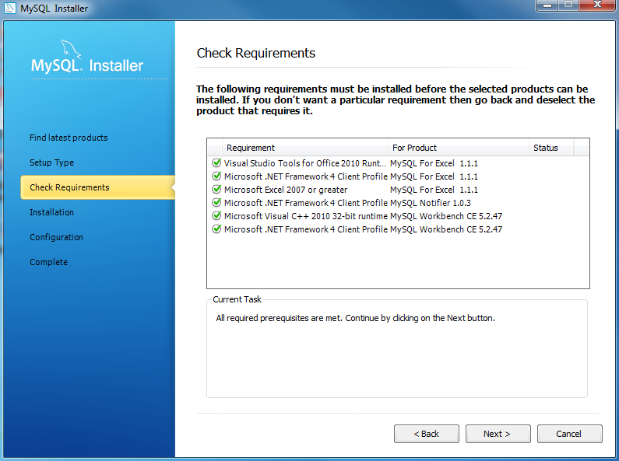

**Step 8:** Checking Requirements

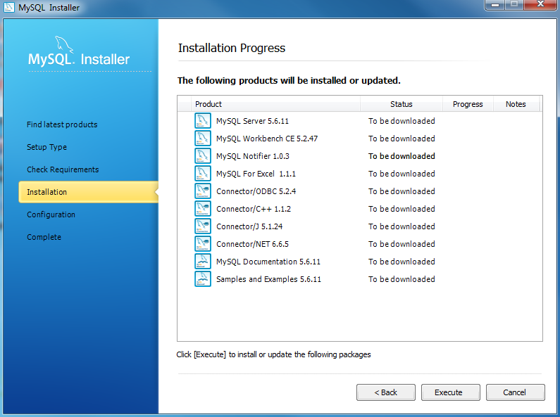

**Step 9:** Installation Progress: MySQL Installer downloads all selected products. It will take a while, depending on which products that you selected and the speed of your internet connection.

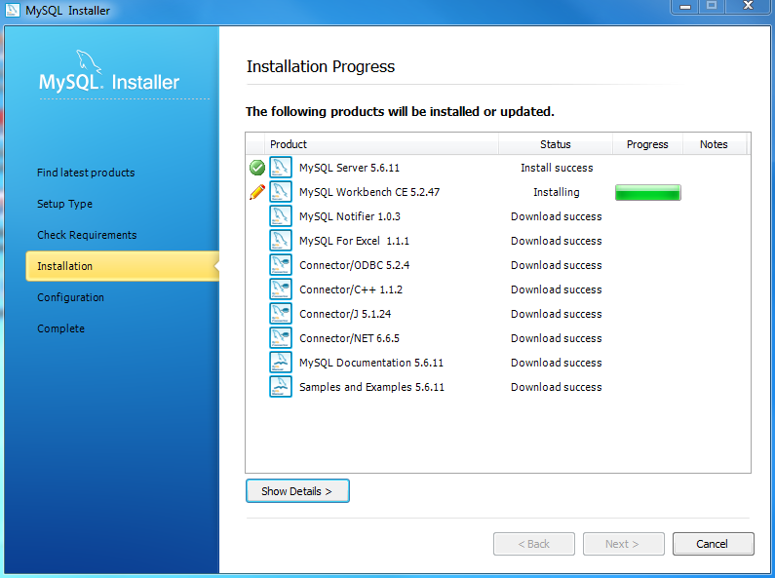

**Step 9:** Installation Progress: downloading Products in progress.

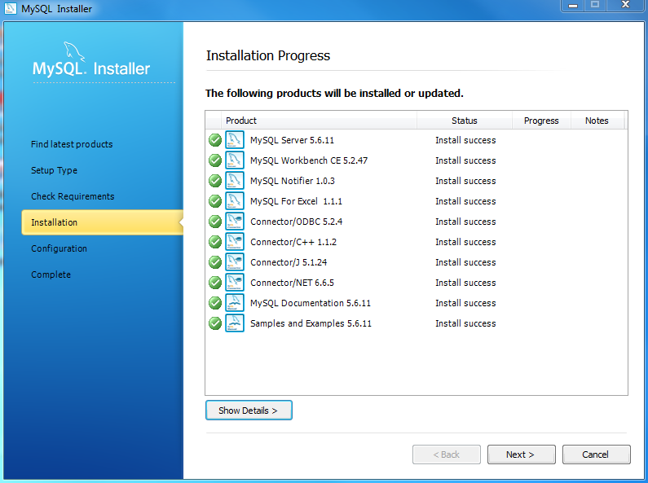

**Step 10:**  Installation Progress: Complete Downloading. Click Next button to continue….

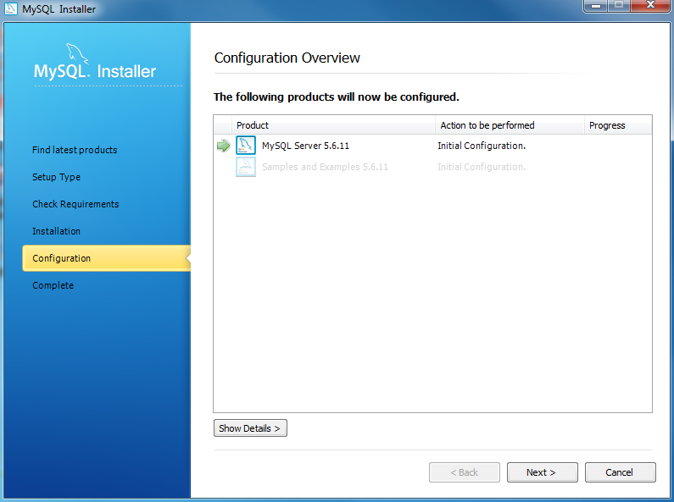

**Step 11:** Configuration Overview. Click Next button to configure MySQL Database Server

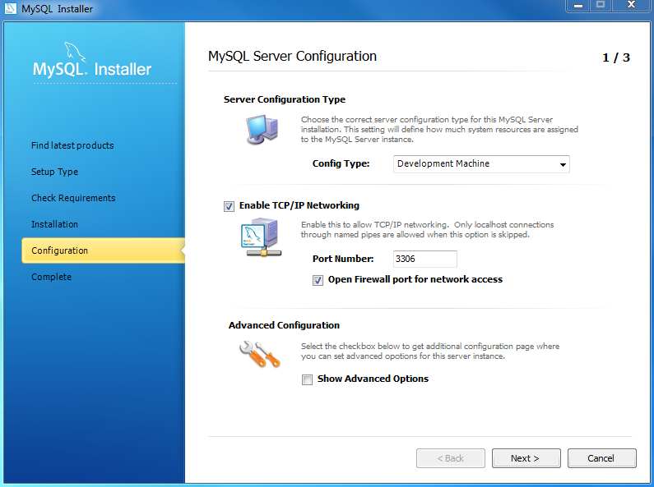

**Step 12:** MySQL Server Configuration: choose Configuration Type and MySQL port (3006 by default) and click Next button to continue.

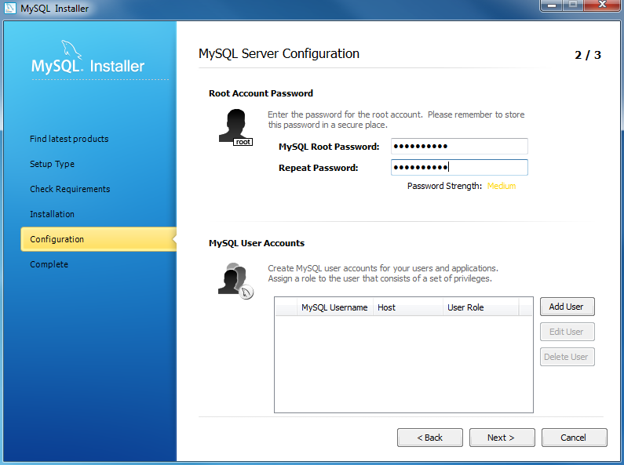

**Step 13:** MySQL Server Configuration: choose a password for the root account. Please note the password download and keep it securely if you are install MySQL database server in a production server. If you want to add more MySQL user, you can do it in this step.

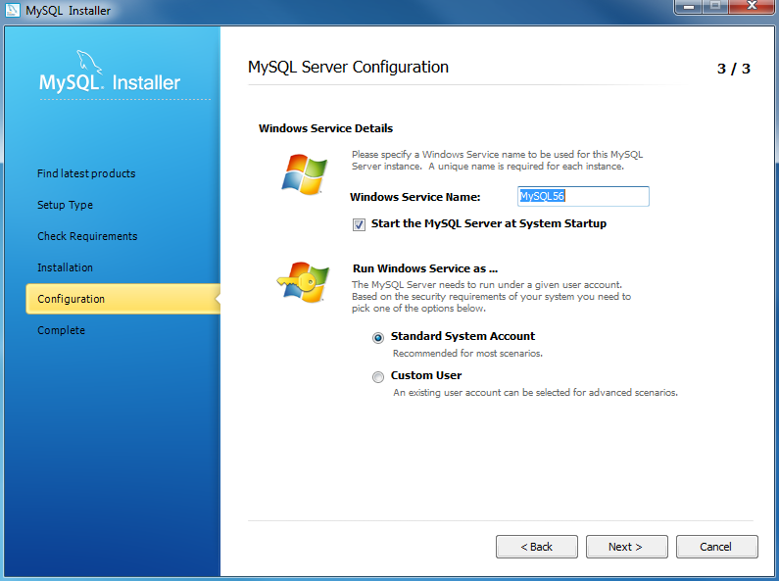

**Step 14:** Configuration Overview: MySQL Installer installs sample databases and sample models.

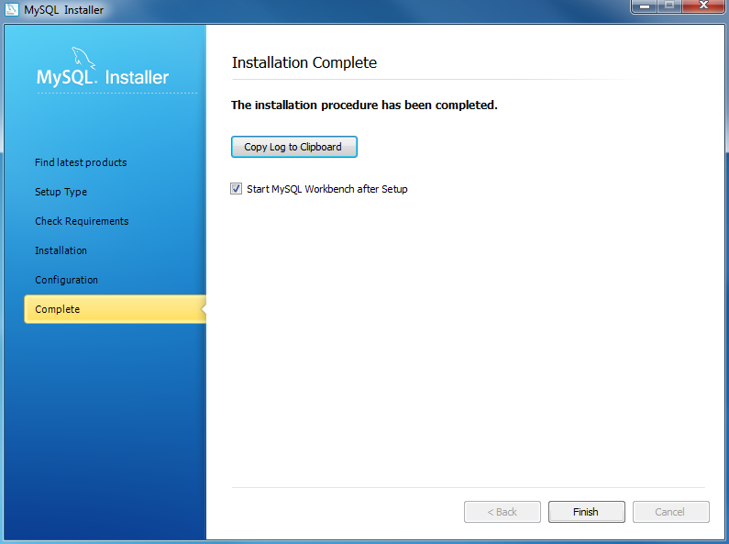

1. My SQL is installed now. If you configured MySQL as a service, then windows will automatically start MySQL server every time every time you restart the system.

**Connect data from MySQL database to Plotly online workspace through Plotly-Connector Database Server:**

**Step 1:** After launching the app, select MySQL by clicking on its icon.

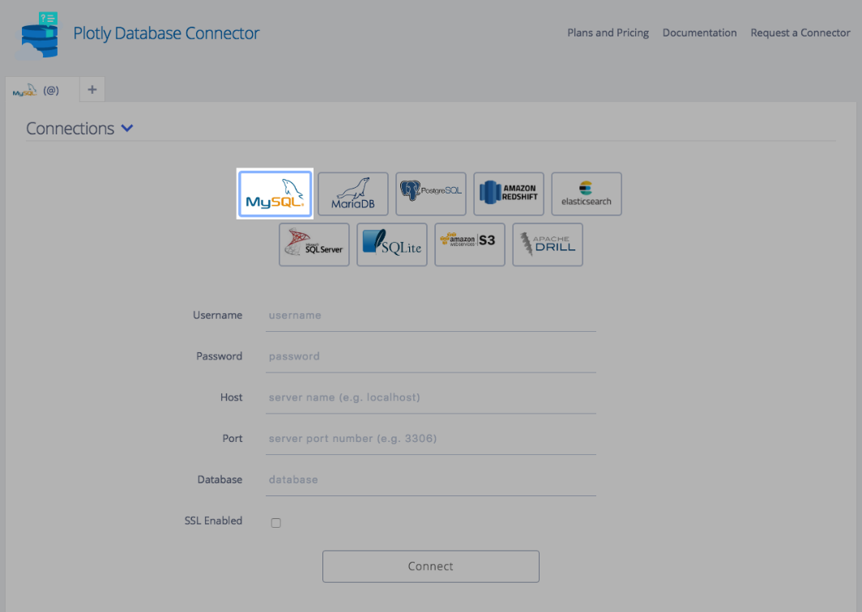

Enter your username, password, database server name (host) and its port number.

**Note:** If you are running your database locally, the host input field can stay empty since its default value is 'localhost'. Similarly, if your database is setup on port number 3306, you may leave the port input field empty as well. If your database is setup on a remote server, simply copy the endpoint name into the host input field and enter the remote server's port number on which your database is located.

Finally, click on the connect button!

**Step 2:** Once connection is established, your connection credentials will be saved and greyed out to avoid unintentional changes. If you wish to modify your connection, click on edit credentials.

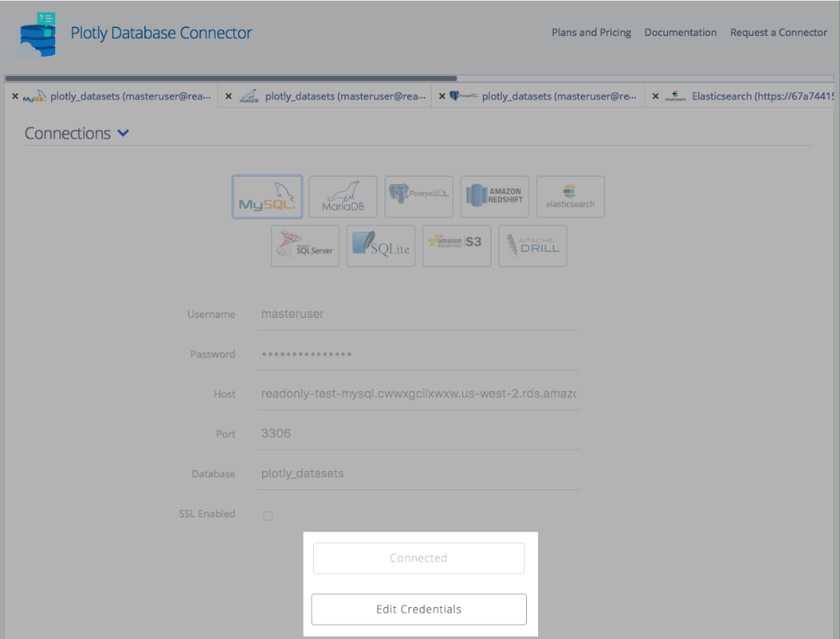

**Step 3:** Preview your tables.

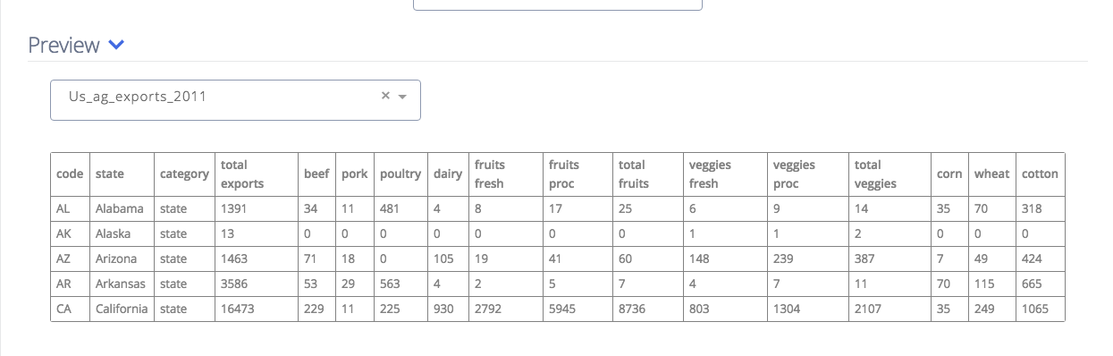

**Step 4:** Send a query to the database. Having connected your app, visit Plotly Chart Creator and click on import data in the top right corner.

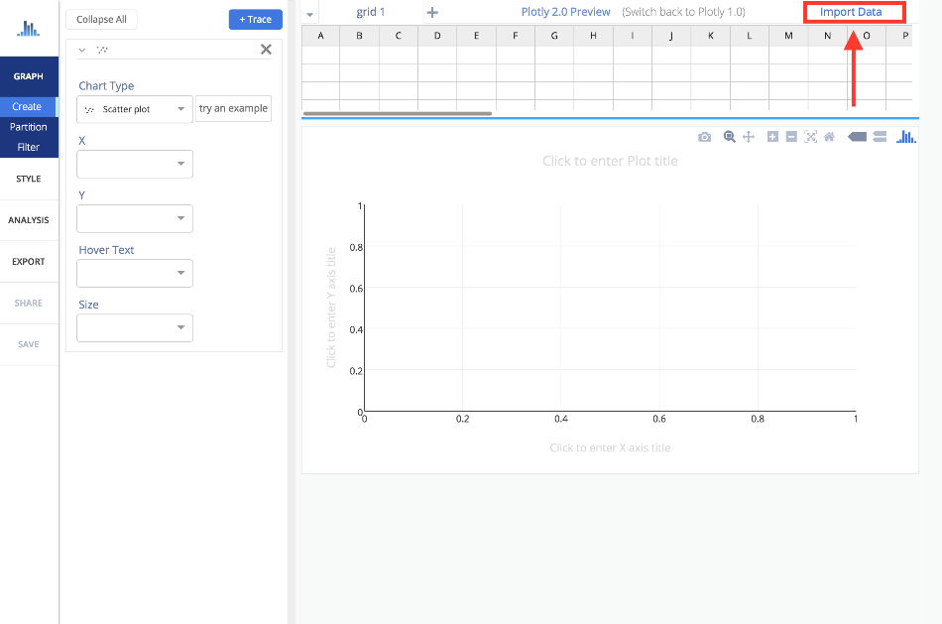

**Step 5:** Choose SQL from the options on the top.

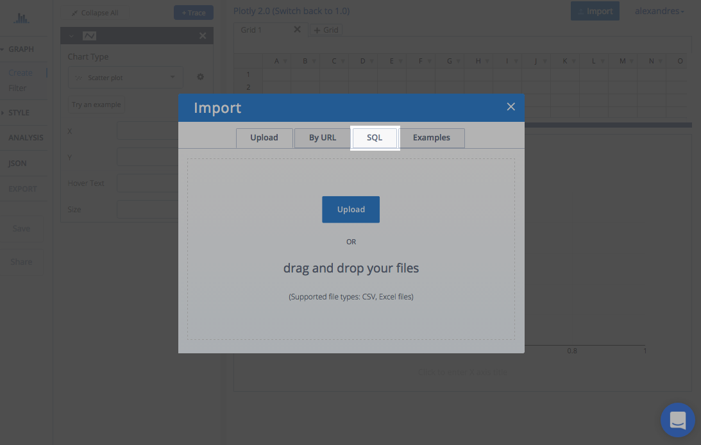

**Step 6:** Click Next

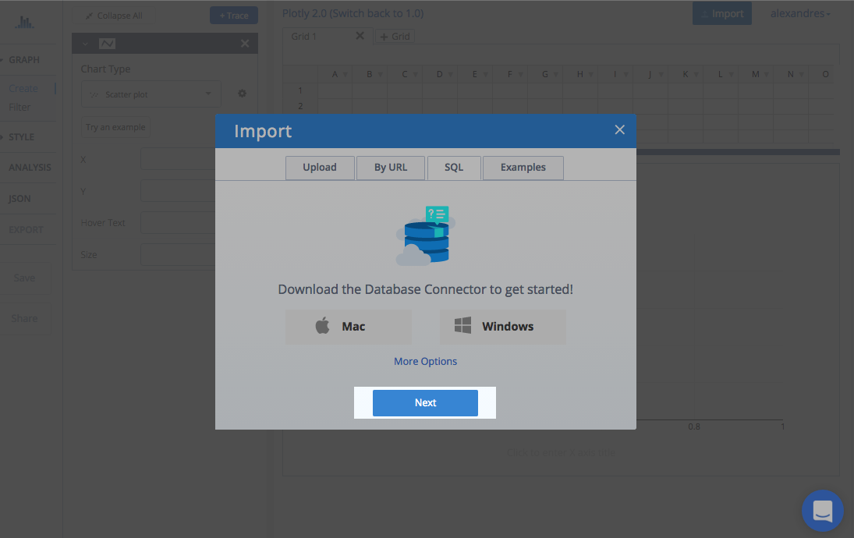

**Step 7:** The modal will close and a new panel will be added to your Plotly Chart Creator.

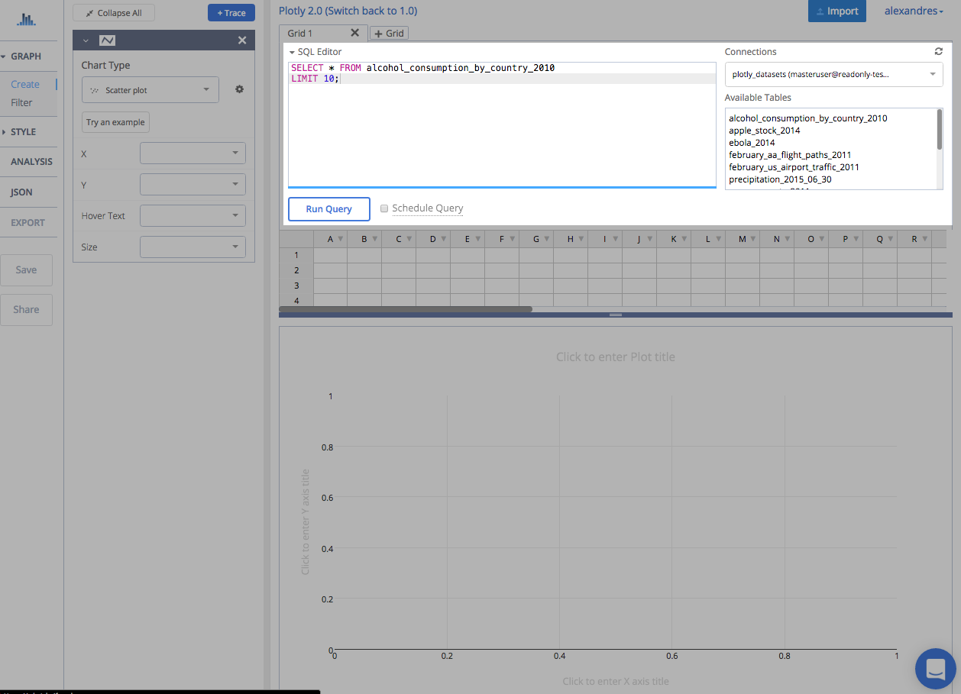

**Step 8:** Once your query is finalized, click Run Query.

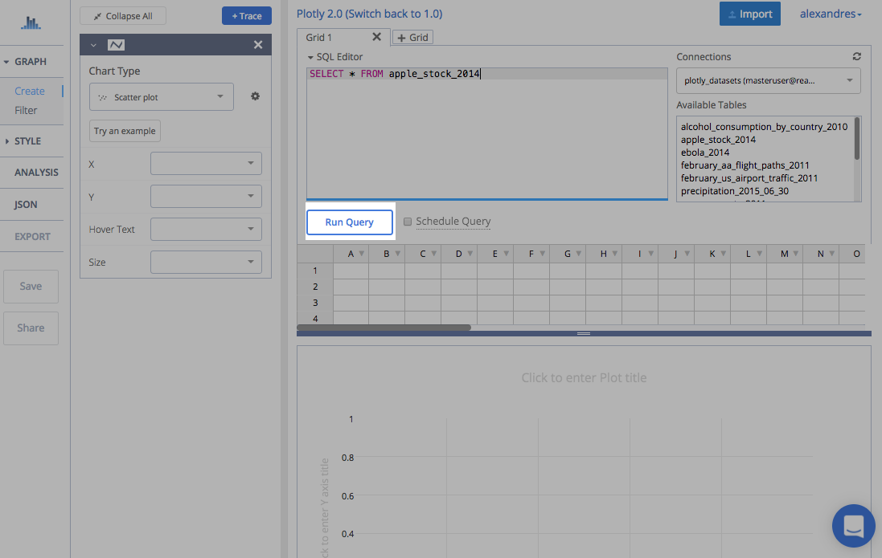

**Step 10:** Explore the plotly and select you graph.

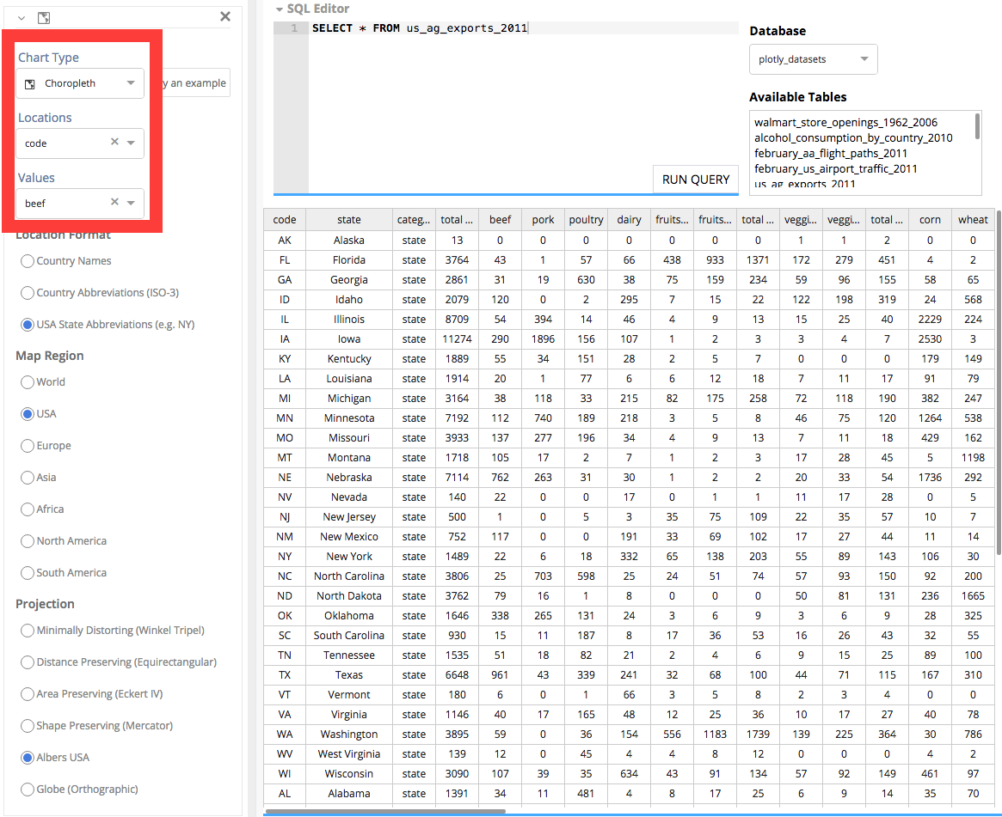

**Step 11:** Resulted Choropleth Chart.

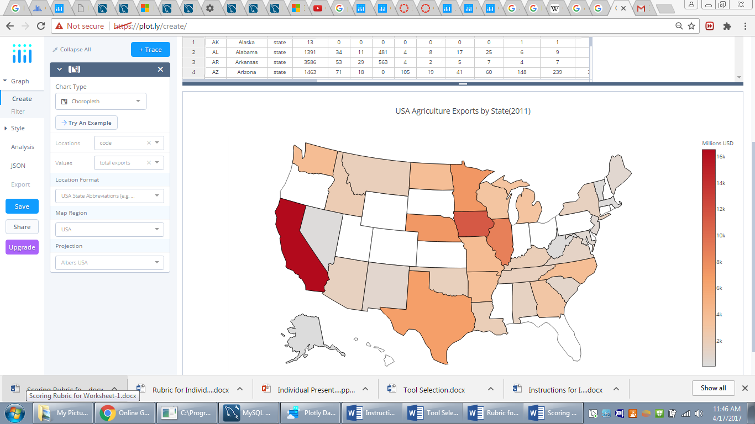

**Step 12:** Follow the same process for the Candlestick chart. Then the resulted output look like

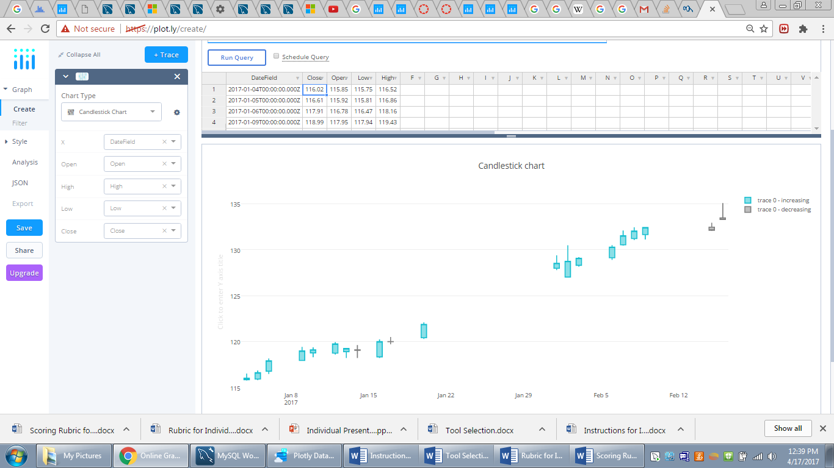

**Conclusion:** By this generating choropleth and candlestick charts in plotly online workspace is completed by importing data from MySQL database.